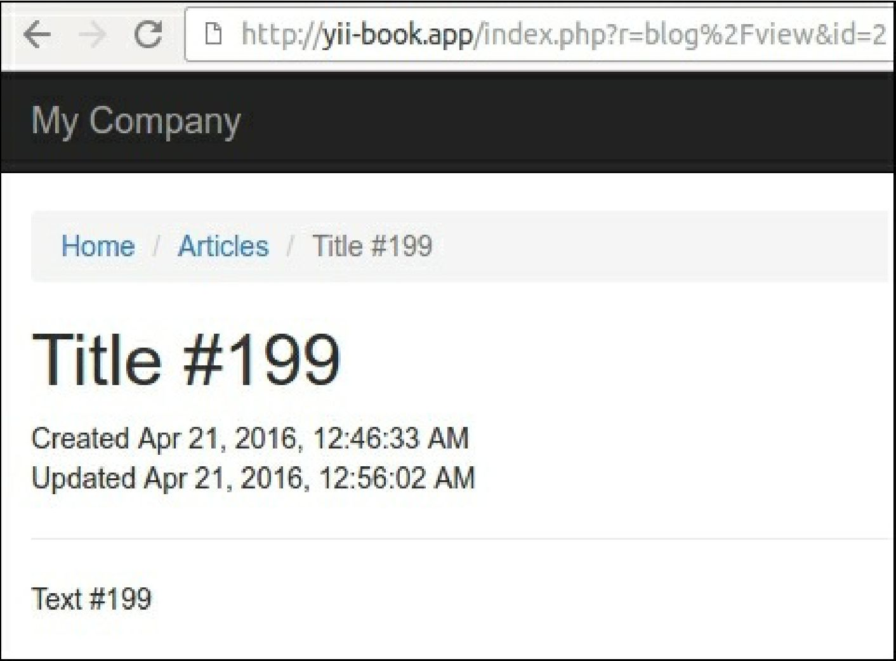

Verify that the server returns 200 ok the first time and 304 Not Modified on subsequent requests.

How it works...

There are time-based and content-based approaches to check the availability of the cached response content for your browser with the help of HTTP-headers.

**Last-Modified**

This approach suggests that the server must return the last modification date of every document. After storing the date, our browser can attach it in the If-Modified-Since header for every subsequent request.

We must attach the action filter to our controller and specify the lastModified callback as follows:

class BlogController extends Controller {

public function behaviors()

{

return [

[

'class' => 'yii\filters\HttpCache',

'only' => ['index'],

'lastModified' => function ($action, $params) { return Article::find()->max('updated_at');